Wise Words - Apocalypse
Gary Wise

I really love Prereleases. I don't do too much playing locally, mostly due to the fact that if I'm paying money for a tournament, I want to give myself every opportunity to win. That means playing with technicalities in mind, which in turn means taking an attitude that is less than conducive to the otherwise tranquil nature of the playing community, so instead, for the last couple of years, I just haven't gone to local tournaments. Prereleases are the one exception. Well, at least until Worlds
When most of the tournaments you play in have a purse of $150,000, the opportunity to play in a tournament whose main premise is the love of the game is a welcome one. For one weekend when each set is released, instead of Magic being my vocation, it becomes my vacation, and the breath of fresh air that results is always a welcome one.
At the Apocalypse Prerelease, I played in three competitions, two flights on Saturday, and the main event on Sunday. Toronto Prereleases, run by FutureQuest, see a Prerelease on Saturday and Sunday, as many 32-person flights and 8-person drafts as they can fill and the Merchant Team Challenge, a promotion that sees players, representing their home stores, play in a three-person Sealed format, with the winners taking home trophies for themselves and banners for the store. I didn't do too well on Saturday, bombing out of both flights I entered before coming 5th on Sunday, which was a nice confidence boost considering the streak I've been on since the beginning of Barcelona.
As a result, of all the fun I had over the weekend, I've been left with a really good feeling about Apocalypse. Apocalypse is great. It's powerful, it's original, and it's skill intensive. Drafting Invasion block will now test one's endurance and patience, with the decision to go three colors early on potentially costing you everything that Apocalypse's diversity has to offer. If this is the end of the world, I'm glad I'm here to see it.
Here then are a few observations that I took away throughout the weekend about the set. Consider this to be a precursor to the Apocalypse limited analysis series, which I'll start working on after US Nats. Here's hoping you'll find this educational and entertaining.

A balance of power
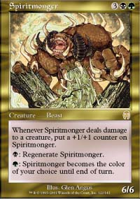
There's no doubt that Apocalypse is an extraordinarily powerful set, but so far I haven't seen any mistakes. Spiritmonger is probably the most coveted card in the set for Limited purposes and yes, it's friggin' powerful, but in the end, it's just a creature. Yes, it's very, very big, and yes, it's hard to kill, but I had one in my first deck Saturday and it was obvious that it was far from impossible to control. Be it Shackles, Manacles of Decay or constant bounce until board control had been established, the Monger was obviously good, but not too good. Not Morphling good, or Masticore good. I think a huge mistake was made not only with the printing of Flametongue Kavu in a format where it's coming-into-play ability could so easily be exploited over and over, but also with the rendering of uncommon status upon it. No matter how powerful the multicolored cards in the set are I just haven't seen anything I don't like about the set as far as the individual cards go.
Also important is the fact that it seems like any color combination can not only be drafted, but can also be successful. In one flight, black-green-blue decks dominated, while in another it was white-blue-red. Cards like Squee's Embrace, Consume Strength and Temporal Spring are all incredibly powerful for their casting costs, but they make it so that all five colors are playable again, and so that they can be played with any other color. There are sixty-six potential color schemes out there, and aside from the mono colored varieties, you'll probably see all of them.

These are a few of my favorite things
These are the cards that have really struck me as being really strong either because of their power, utility or function:
Lay of the Land - Okay, don't be picking this first, but in any deck that sees green as a base color, this card is great, providing you with the colored mana you need as soon as you need it. This thing is so cheap! It diversifies your mana and lowers the necessary land to spell ratio of your deck, all the while thinning the deck out whenever you cast it. Great stuff.
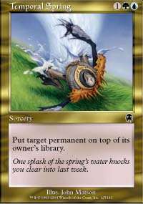
Temporal Spring - Oh man, when I first saw this card... I was always a huge fan of Time Ebb for the tempo advantage it was able to provide along with the possibility of a little card advantage for when a creature happened to get enchanted, but this thing takes it a step further. The ability to target a land makes it possible to cast your Serpentine Kavu (with help from an Elf or Fertile Ground) before your opponent gets their third land in play, and the fact there will always be a target for the Stream on turn three makes this card an unbelievable beating.
Raka Sanctuary - All the Sanctuaries are very strong when fully active, but none of the others come close to this one. This may be the best blue-white card in the set, which is kind of funny considering its own color scheme. I always liked the Abyss, but I think it would have been a lot better if it only targeted your opponent's creatures. Now, it does.
Dodecapod - I got hit by a Blazing Specter on Saturday, and all I got for my troubles was a 5/5 creature that required no mana to get into play. As a 3/3 for four whose mana requirements are amazingly simple in this mana-insane environment, this thing would be great without the discard ability, but its that aspect of it that takes it over the top. There are SO many discard spells in this environment that people play, from Rats, to Bog Down, to Hypnotic Cloud to Probe that go from good to bad in a hurry when this thing is in your hand. Just a great, great card.
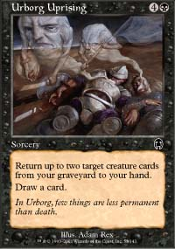
Urborg Uprising - This card is unbelievable. Time and again over the weekend, I'd be watching matches that had slowed to a standstill when one player would cast the Uprising and absolutely demolish their opponents. Sure, it's expensive, but it's an easy expensive, and you get three cards, two of which you choose, for one. If it was good this weekend, imagine how good it will be when you can start choosing Lava Zombie and Flametongue Kavu as your two targets.
Fire/Ice - Here we have a split card that on the one hand is better than Scorching Lava, and on the other hand is better than, um, Enervate (OK, that isn't the most ringing endorsement). Basically, take a Scorch, make it capable of mass kill and give it an alternate ability... the card is great.
Life/Death - G? That's it? You drop nine lands into play, tap one and attack for one with the other eight. Insane? Yes, the fact is that Life's being a sorcery limits its versatility, but that's made up for by its reflection, Death, which also provides a plausible use. When you're beating down, any creature is a good creature for two mana, so you have here a card that either aids you in beating down or lets you wait and finish an opponent off in the long game.
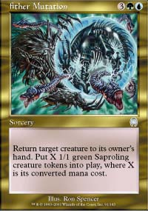
Aether Mutation - While playing a fun game Sunday, my opponent cast Yavimaya's Embrace on my Dodecapod, and my only reaction was 'that's a whole lot of mana to spend just to give me some 1/1 creatures'. Aether Mutation is time advantage personified, not only returning your opponent's huge creature, but also providing you numerous tokens who either stop it for a few more turns, trade with opposing creatures or swarm for the kill. It also fits right in with the blue-green theme of attacking after pushing your opponent's dudes out of the way and kills creature enchantments. I think that's enough.
Squee's Embrace - How shall I abuse thee, let me count the ways. Turn 2, Goblin Legionnaire, turn three attack for four, turn four, attack for four, turn five, attack for four, turn six, attack into the gang block, damage on the stack, activate the Legionnaire, kill three guys, get the Legionnaire back. Anyone want to try Penumbras? How about 8/8 Dragons?
Vindicate - The rich man's Temporal Spring, Vindicate is the nuts. No, it isn't pure card advantage, but who cares? It's a black card that Disenchants, a white card that Banishes and some sick, twisted combination of Stone Rain, Desert Twister, Terminate, Emerald Charm and Crash. Now tell me, would you rather have all of them or just the Vindicate? 'What were they thinking?' will be the most asked question about this card. The answer is 'This is the Apocalypse, the end of all there is. That means lots of big cards with big effects. Enjoy.' Welcome to the end.

Draft Strategies
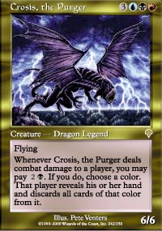
Do you play Dragons?
Is it possible that opening a Dragon is a bad thing? Think about it: with the gold cards in Apocalypse being as insanely powerful as they are, you'll want to try and exploit them by drafting two side-by-side colors (say, green and red) and then exploiting the gold cards they share with their opposite (blue) with a splash (i.e. Splash Temporal Spring and Quicksilver Dagger). Or, you can force two opposing colors (say black and white) so you can choose from two colors to splash (green for green-black cards or red for red-white cards). Thing is, If you open a Dragon, you can do either of the above, meaning you'll only have access to one cross-color combination if you stay within the parameters of a three color deck.
Thus far, I've enjoyed some success drafting neighboring colors and splashing the opposite, but the possibilities are endless. You can draft R-G-u (upper case letters label a main color, lower case letters a splash) or R-U-g or you can draft the Dragon colors, or for those brave souls out there, you can try to draft two or five colors. The possibilities are endless. As much temptation as Invasion and Planeshift offered to stray from the two color path, Apocalypse makes you want to stray from three, and that means more than ever, your mana and your patience will be of the utmost importance.
That's about it for this week. As always, if you have any specific questions, feel free to e-mail me at JGaryWise@yahoo.com. Have a good week.

